TITLE OF THE TWO-PAGE ABSTRACT (14pt, bold)

First AUTHOR1, Second AUTHOR2, Third AUTHOR3, … (FullGivenName SURNAME, 11pt, bold)

1. ORCID, Affiliation, Address, City, Country, E-mail: [first.author@univ.com](mailto:first.author@univ.com); (10pt, regular)
2. ORCID, Affiliation, Address, City, Country, E-mail: [second.author@univ.com](mailto:second.author@univ.com); (10pt, regular)
3. ORCID, Affiliation, Address, City, Country, E-mail: [third.author@univ.com](mailto:third.author@univ.com); (10pt, regular)

# Introduction

Please use this template to prepare the two-page extended abstract for the 41st Danubia-Adria Symposium on Advances in Experimental Mechanics, which will take place in Kragujevac, Serbia, between September 23-26, 2025.

All formatting data is contained in the template, so you can simply insert the text, tables, equations and figures in this file. Please respect this format in order to make the editor’s work easier.

# Format of the text

The text should be written with Times New Roman 11pt, justified, single-line spacing. The first line will be indented with 0.5 cm. Paragraphs will have 6pt spacing before.

The contribution title should be in bold 14pt Times New Roman capital font. The authors’ names should be written in Times New Roman 11pt bold with upper indices for details, and authors’ details (ORCID, address, e-mail) in 10pt Times New Roman font, all centered.

The section titles will be written with 12pt bold, 12pt spacing before, and 3pt spacing after.

Excepting title and authors, all text will be written in two-column format. Each column will have a width of 8 cm, with 1 cm between columns.

The text throughout the contribution should be structured into the following sections: Introduction, Materials and methodology, Results, Conclusions, Acknowledgements, and References.

## Subsections

Subsection titles must be written with Times New Roman, 11pt italic, 6pt spacing before, and 3pt spacing after. Each section can be divided into one level of subsections, if necessary.

# Page setup

The header and the footer cannot be changed. Please do not insert page numbers into the footer. All text will be formatted with the Page Setup shown in the figures below:

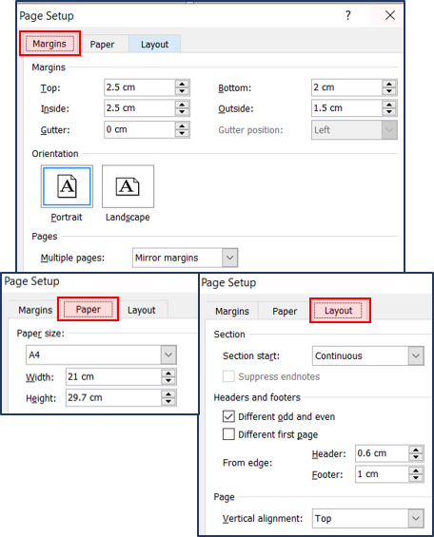

**Fig. 1.** Figure legend here (10pt, centered).

# Figures

Figures should have a width of a maximum 8 cm and will be addressed in the text as Fig. 1, Fig. 2, etc. The legend of the figure should be written below the figure, with Times New Roman 10pt, centered, 6pt spacing before. Only the text “Fig. 1.” is written in bold.

Ensure that the quality and the resolution of the figures are high enough. The font size of the text annotations in a figure should be at least 6pt.

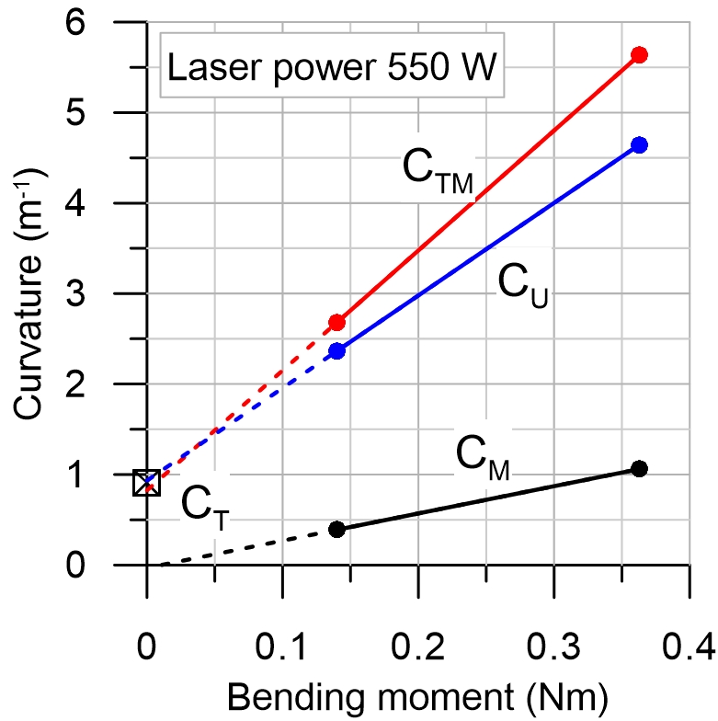

**Fig. 2.** Figure legend here (10pt, centered).

# Tables

Text in the tables must be written in Times New Roman, 10pt. Numbers in the table should be aligned right. If more columns are necessary, the height of the text can be lowered to 9pt in order to fit in the cells. The legend of the table should be written above the table, with Times New Roman, 10pt, centered. Only the text “Table 1.” is written in bold.

**Table 1.** Table legend here. (10pt, centered)

|  |  |  |  |
| --- | --- | --- | --- |
| **Case no.** | **Force**  [N] | **Stress**  [MPa] | **Strain**  [%] |
| 1 | 156000 | 156.00 | 0.0742 |
| 2 | 242350 | 242.35 | 0.1154 |
| 3 | 156000 | 156.00 | 0.0742 |
| 4 | 242350 | 242.35 | 0.1154 |

# Equations

All equations should be written in Times New Roman, 11pt. They need to be centered using tabs and numbered on the right side in rounded brackets.

Equations need to be inserted using the built-in equation editor of Microsoft Word and must be referenced in the text as Eq. (1), for instance.

$f\left(σ\right)=\frac{1}{2}\left(s-α\right):\left(s-α\right)-\frac{1}{3}σ_{0}^{2},$ (1)

$\dot{σ}=λ∙tr\left[{\dot{ε}}^{el}\right]I+2μ∙{\dot{ε}}^{el}$. (2)

# Citations and references

Cited papers, books, websites should be referred to in text by the reference number in square brackets, following the Science and Engineering citation style. The references have to be listed in the order of appearance and cited, as shown in the examples at the end of this template. The format of the reference [1] is for a journal paper, reference [2] for a conference paper, reference [3] for a book and reference [4] for websites.

You can find abbreviations of journals here: <http://images.webofknowledge.com/images/help/WOS/A_abrvjt.html>

Please do not use more than ten references in the abstract because they require too much space.

# Submission

The two-page abstract must be submitted electronically via [https://www.das2025.fin.kg.ac.rs/abstract-guidelines/.](https://www.das2025.fin.kg.ac.rs/abstract-guidelines/)

# Conclusions

All new contributions of the paper’s authors should be summarized in the conclusion section. Please clearly identify the main novelty of the article.

# Acknowledgments

It is possible to write acknowledgments for the projects and supporting institutions.

# References

1. Suo, Z., Kuo, C., Barnett, D., Willis, J. Fracture mechanics for piezoelectric ceramics. *J Mech Phys Solids*, 1992, 40(4), 739–765.
2. Johnson, A., Byles, B. Experimental determination of fracture parameters in composites. In *Proceedings of the 25th International Conference on Advanced Materials*, Barcelona, 6-9 Dec, 2015; Kay, L., Smith, B.B., Eds.; Martel Publishing House, Barcelona, 2015; pp. 123–129.
3. Anderson, T. L. *Fracture mechanics: fundamentals and applications*; CRC Press: Boca Raton, 2017.
4. *Bone fracture*. <http://www.nmihi.com/b/bone-fracture.htm>. Accessed October 5, 2023.